

JUMEIRAH COLLEGE PRIMARY SECTION

Newsletter

Head of Section: Mr Chris Wright vol: 03/04 issue 3 November 03

P.O BOX 72573, DUBAI, U.A.E. Tel: + 971 4 3944813 Fax: + 971 4 3944812 E-mail: jcpsadmin@jcdubai.sch.ae

Introduction

It is our intention during the year to keep you informed of activities, news and events via our newsletter. These will be issued during the first week of each month and more often as required.

JCPS Charity Ball

With your help the inaugural JCPS Charity Ball will be the social event to be seen at in the lead up to the Christmas period. Taking place on Thursday 4th December at the Fairmont Hotel this Black Tie Ball will not only be a social event to remember it is expected that it will generate 40,000 Dhs for the school’s supported charities of the Red Crescent Society, the Rashid Pediatric Therapy Centre and the Al Noor Training Centre for children with Special Needs.

With a theme of ‘It’s a Small World’ the organising committee under the direction of Mrs. Sharin Gaille have been very busy in ensuring the night is a success. One of Dubai’s top DJs have been booked to help us dance the night away, a gastronomic buffet is planned and raffle prizes which include ‘airline tickets’ to exotic places have already been donated. African + Eastern have donated welcoming drinks and wine for tables.

Tickets priced Dhs 225 will go on sale from Sunday, November 9th. Each morning from 7.30 - 8.15 a.m. a member of the organising committee will be at a table under the covered walkway by the Nursery. Pease enter the school via the Park & Shop gate. We will offer a cocktail reception, then an international buffet dinner with wine (4 bottles per table), dancing, and fabulous raffle prizes.

You are able to ‘book’ tables of 8 on a first come first served basis or if you are unable to raise a full table the committee will ensure you a seated with a ‘good crowd’. You will be most welcome to invite friends who are not JC parents.

The committee are still looking for prizes for the raffle so if you know of any one who might be willing to donate a prize please contact Mrs Sharin Gaille 050 6559605.
Parent / Teacher Consultation Evening

We thank all parents who attended this event and the teaching staff who gave freely of their time. 92% of parents met with teachers.

Class Assemblies

It gives the school pleasure to be able to invite parents of each class to join us at this time. The assemblies will take place each Tuesday morning at 8.15 a.m. in the Examination Room of the Secondary Section.

The schedule for the remainder of this term is as follows:

11 November Class 2F
18 November Class 2W

We hope very much that you will put these dates in your diary now so that you will be able to join us.

Classes that have not lead an assembly this term will take their place on the rota between 13th January and 23rd March 2004.

Christmas Concerts / Special Assemblies

We are pleased to announce the following schedule for ‘Festive Performances’ to which parents are invited to attend.

Tuesday 9th December - Exam Hall

0830 Reception and Nursery
- Year 1 and 2

Wednesday 10th December – Exam Hall

0830 Year 1 and 2 (repeat)
1230 Reception and Nursery

The above performances will be repeated to allow all parents an opportunity to attend ONCE and secure a good view. Ticket allocations so we can spread our audience equally will be made in the week proceeding according to your preferences. We apologise for no ‘Evening Performance’ but it is not thought to be in the best interest of our younger pupils to be back at school late at night.

Monday 15th December – Sports Hall

1900 Years 3, 4, 5 and 6

Payment of School Fees

From the start of this school year parents have the facility to pay school fees by any major credit card at the Accountant Office. Those of you that bank with Mashreqbank can now pay school fees ‘online’ from the comfort of your home or office.

As a mashreqonline user, logon to mashreqonline, select ‘Payments’ and then click ‘MashreqPayPlus’ to pay the fees. If you are not a mashreqonline user, call 04 2174800, press 2,4 and activate yoru TIN to logon to mashreqonline.
Coporate customers should logon to mashreqbusinessonline, select the ‘MashreqPayPlus’ option from the transaction menu to carry out the transaction.

All fees should be paid within two weeks of issue of invoice from the Accountants Office.

Congratulations to ……

 winners of Mr.Wright’s Special Award certificates for October. All children who are sent to Mr Wright during the week are recorded in a special book and their name read out in the weekly assembly.
Thomas Millar (5H), Madeline Leigh (5P), and Jasmine Hay (1D)

One pupil who in the opinion of Mr Wright has shown good progress / work / behaviour is awarded a special certificate.

Swim Galas

In the last newsletter we announced a number of swimming galas in which our JCPS team were taking part.

Mr Winders has been delighted by the response and team spirit our young swimmers generated and their willingness to swim in events that were not their normal to help complete teams. Special mention to Ricko Van Straaten (Y3) and Kylie Keen (Y4) who swam in Year 5 and Year 6 races.
In the Oz Gala held over the weekend of 9/10 October, JCPS competed against schools from Kuwait, Oman and Muscat. Our heartiest congratulations go to Francesca Scalpello, Laura Jelfs and Matthew Grayston. Between them they entered 10 races and collected 2 GOLDS, 3 SILVERS and 3 BRONZE medals!!

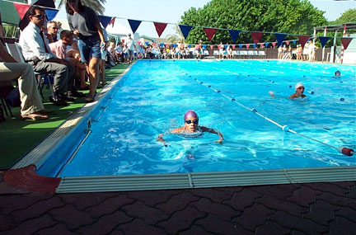

Laura Jelfs wins the breaststroke at the JESS gala

Individual Portrait photographs

These have been sent home with your child on a sale or return basis. Prompt return of either photograph or the fee to Mrs Dacre will be appreciated.

School Closures

Please look to the local press for confirmation but it is envisaged that the school will be closed on

Monday 24th November, Tuesday 25th November, Wednesday 26th November for Eid-Al-Fitr celebrations and

Tuesday 2nd December and Wednesday 3rd December for National Day celebrations.

Book Sale

There will be a sale of Motivate books in the library on Wednesday 19 November from about 10.00am until 2.00pm. For those of you new to the region, Motivate is a good local publisher in Dubai, which concentrates on publications about the Gulf region and the culture here. They usually offer very good prices at these annual sales, and have a new 2003 catalogue available. These make excellent "coffee table" presents for the coming festive season, if you're planning to head home!

Parents are welcome to come up to the library, and to browse in the book sale at any time during the above mentioned times. Please enter the school via the Main Entrance and collect a visitor badge before going up stairs to the Library.

All sales will result in the library obtaining a good discount to be able to purchase new books too. Thanks for your ongoing support.

Mrs Martin. Librarian.

International Day

Already there has been an enthusiastic response to our request for help with our International Day celebrations on the 30th Nov and 1st Dec. Parents have offered to help prepare and mount displays for over 20 countries represented at the school and many have kindly volunteered to run activities related to these. We still however need parents to help either bodily or with ideas/resources for activities related to New Zealand, China, Lebanon, Pakistan, France, Spain and Georgia.

If you can offer any traditional skill that would be relatively simple and fun for kids we’d love to hear from you.

Also if you have any photographs, pictures, artefacts, flags, traditional children’s stories, clothes, fun language /colouring worksheets etc. related to one of the following countries then please forward to Cath Ratcliffe (Class 3R) - Multicultural Coordinator who will ensure their safe return.

South Africa Lebanon Zimbabwe Georgia USA Sri Lanka New Zealand Pakistan Wales
China France England
Scotland Spain Austria Russia Iran Croatia Algeria India Canada Australia Ireland

All pupils will be invited to attend school on 1st December wearing their National Costume or dress as a famous person from their home land. (not modern day so no David Beckhams – thank you)
The Nursery Class get into the ‘spirit’ of Halloween. As well as dressing up time was spent playing traditional games.
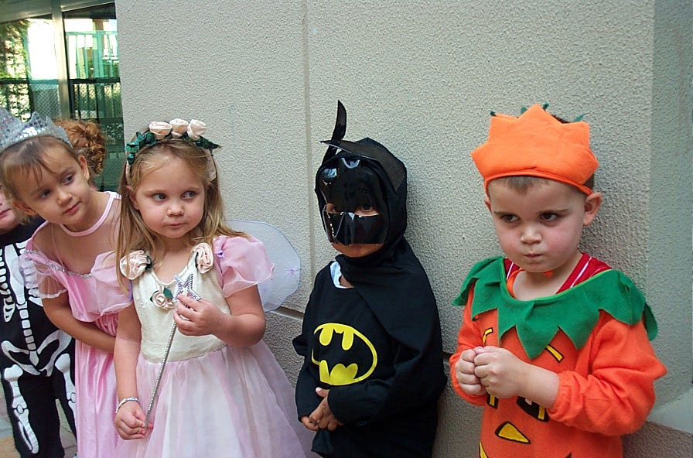
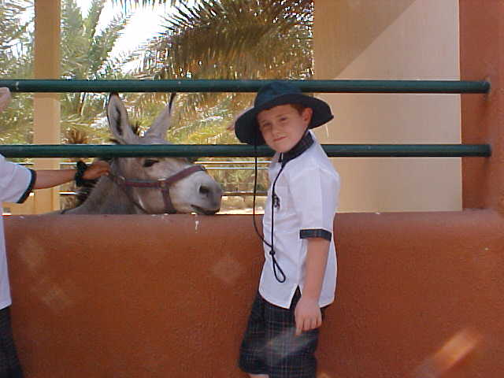

Year 3 visit Sharjah Wildlife Park –
Joshua Blakemore (3B) reports

What made this trip successful was that we didn’t have to go on a bus that didn’t have very good seat belts, which was very good.

We were very excited when we got on the bus, we sang songs, played games and some of us fell asleep, including Miss Booyzen!

We soon got off the bus and wandered inside the first building. The first creatures we saw were reptiles. Although I didn’t see their teeth I bet they were carnivores anyway. I saw other animals like cheetahs, flamingo, a leopard, bats, a sand cat, baboons and a Arabian wolf stalking a bird which was really special. But my favourite was the little cute Arabian fox.

Next we went to the Children’s Farm. Luckily it was feeding time so we got to feed camels, goats, cows, donkeys and of course the horses. Miss Booyzen was a little afraid but us children had a lot of fun.

Footnote: The trip was scheduled for two days before it actually took place. A new bus company had been booked which had been recommended to us. When the buses arrived we were not satisfied with the quality of the seat belts and they were therefore sent away and the trip re-scheduled. Whilst this created initial disappointment for the children, their safety on any school trip is paramount and as you can see from the report it didn’t stop them enjoying this worthwhile visit. Mr Wright

Other trips that have taken place last month include: The Nursery class visited Umm Suqeim Park and Baskin Robbins, Year 1 visited Children’s City and all four Reception classes visited Umm Suqeim Park.

